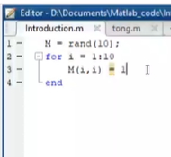

Giải 3 câu cuối

<https://www.youtube.com/watch?v=CcneV0JoTPo&ab_channel=%C4%90%E1%BB%A9cHuyL%C3%AA>